Using Square-Wave analysis we calculate the low critical frequency using Fractional Tilt and the below formula.

$$fcl= \frac{fractional tilt}{2πPW}$$

* 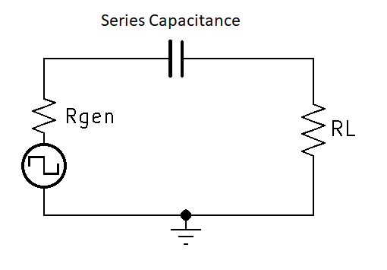Consider the following circuit:
  + Series capacitance will allow high frequencies through but may affect or attenuate lower frequencies.
  + The vertical components of the square wave (rising and falling edges) represent a fast transition and the high frequency component of the waveform.
  + The horizontal components of the square wave represent higher to lower (left to right) Frequencies of the Odd Harmonics.
  + 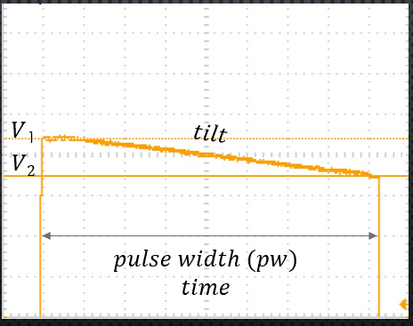This is what gives us “tilt”. Xc of the series capacitance increase at lower frequencies thus attenuating the lower frequency odd harmonic components at the output.

We can in fact derive the above equation from the standard Capacitor Reactance and Charge Formulas.

Xc =

* Observe that the waveform (tilt) across the pulse width appears to be a similar to a capacitance discharge.
* Let’s think about this problem in terms of the capacitor charge formula.
  + = V2 (discharge)
  + = 0
  + = V1
* Now let’s think about the tilt formula in terms of the capacitor charge formula.
  + Fractional tilt = $\frac{V1 -V2}{APA}$ or $\frac{∆V}{Vavg.}$
* Now what if we put the Fractional tilt formula in terms of our previously defined Vc formula.
  + Fractional tilt (Vc formula) = $\frac{Vin -Vc}{\frac{Vin+Vc}{2}}$ or $\frac{2(Vin-Vc)}{(Vin+Vc)}$
* Fractional tilt (vc formula) = or $\frac{2(Vin-Vc)}{(Vin+Vc)}$
* Assume fractional tilt is equal to 0.10 and solve for Vc
  + 0.10 = $\frac{2(Vin-Vc)}{(Vin+Vc)}$
  + 0.10 $(Vin+Vc)$ = $2(Vin-Vc)$
  + .1 $Vin$ + .1 $Vc$ = 2 $Vin$- 2 $Vc$
  + 2.1 $Vc$ = 1.9 $Vin$
    - Vctilt0.01=
* Discharge formula simplification with Vc tilt substitution
 $Vc=vfin -\left(vfin -vin\right)e^{\frac{-t}{RC}}$

 $Vc=0 -\left(0 -vin\right)e^{\frac{-t}{RC}}$

$Vc=\left(vin\right)e^{\frac{-t}{RC}}$

+ Substitute $Vc$ 0.10 frac. tilt
 $\frac{1.9Vin}{2.1}=\left(vin\right)e^{\frac{-t}{RC}}$

 $\frac{1.9Vin}{2.1\left(vin\right)}=e^{\frac{-t}{RC}}$

$\frac{1.9}{2.1}=e^{\frac{-t}{RC}}$

$\ln{\frac{1.9}{2.1}}$ + = $\frac{-t}{RC}$

Further simplify and solve for RC

* + =
  + -.100083 = $\frac{-t}{RC}$
  + $RC$ = $\frac{t}{\text{.100083}}$

Observe that $t$ represents time of the tilt

* + =
  + .100083 $≈$ 10% or fractional tilt
  + $RC$ = $\frac{pw}{*fractional tilt}$

Verify correlation of fractional tilt

* + Solve at 5% tilt
  + Fractional tilt (vc formula) = or $\frac{2(Vin-Vc)}{(Vin+Vc)}$
  + .05 = $\frac{2(Vin-Vc)}{(Vin+Vc)}$
 $vc=\frac{1.95vin}{2.05}$

 $\frac{1.95vin}{2.05}$ + = $\left(vin\right)e^{\frac{-t}{RC}}$
  + $\ln{\frac{1.95}{2.05}}$ = $\frac{-t}{RC}$
  + -.050104 = $\frac{-t}{RC}$
  + .050104 $≈fractional tilt$

$RC= \frac{pw}{fractional tilt}$

At frequency cutoff low, Xc = Rthev

* + Substitute RC fractional tilt formula

$RC= \frac{pw}{fractional tilt}$

$fCL= \frac{1}{2π\frac{pw}{fractional tilt}}$

$fCL= \frac{fractional tilt}{2πpw}$